LPBH Approach
How it work?
1️- Convert Image to Grayscale
- The LBPH algorithm works on grayscale images because it focuses on texture rather than color.
2️- Divide Image into Small Grids (Cell Blocks)
- The image is divided into small 3×3 pixel blocks (local neighborhoods).
3️- Compute Local Binary Pattern (LBP) for Each Pixel
- For each central pixel, compare it with its 8 surrounding pixels.
- If the surrounding pixel is brighter than the center, assign 1; otherwise, assign 0.
- Convert this binary pattern into a decimal value.
4️- Create a Histogram for Each Region
- Each small region of the image has its LBP values converted into a histogram.
- The histograms from all regions are combined into a single feature vector.
5️- Train a Face Recognition Model
- The feature vector is stored along with the person's ID label.
- When a new face is detected, the model compares the new feature vector with stored histograms using Euclidean distance.
- The closest match is used to determine the identity.
How LBPH Recognizes a Face?
- During training, LBPH stores the histograms of known faces with their labels.
- During recognition, the model extracts the LBP features from the detected face, then compares it with stored histograms.
- The closest match (based on distance metrics like Euclidean distance) is selected as the identity.

- Advantages of LBPH
✅ Robust to Lighting Changes : Since LBPH focuses on textures, it is less affected by lighting conditions.
✅ Works with Small Datasets : Unlike deep learning models, LBPH does not need large datasets to perform well.
✅ Fast & Simple : LBPH is computationally efficient and can run on low-power devices.
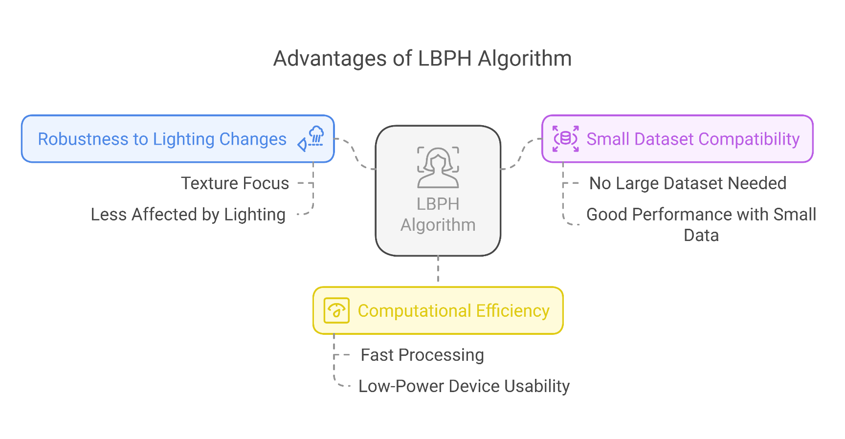

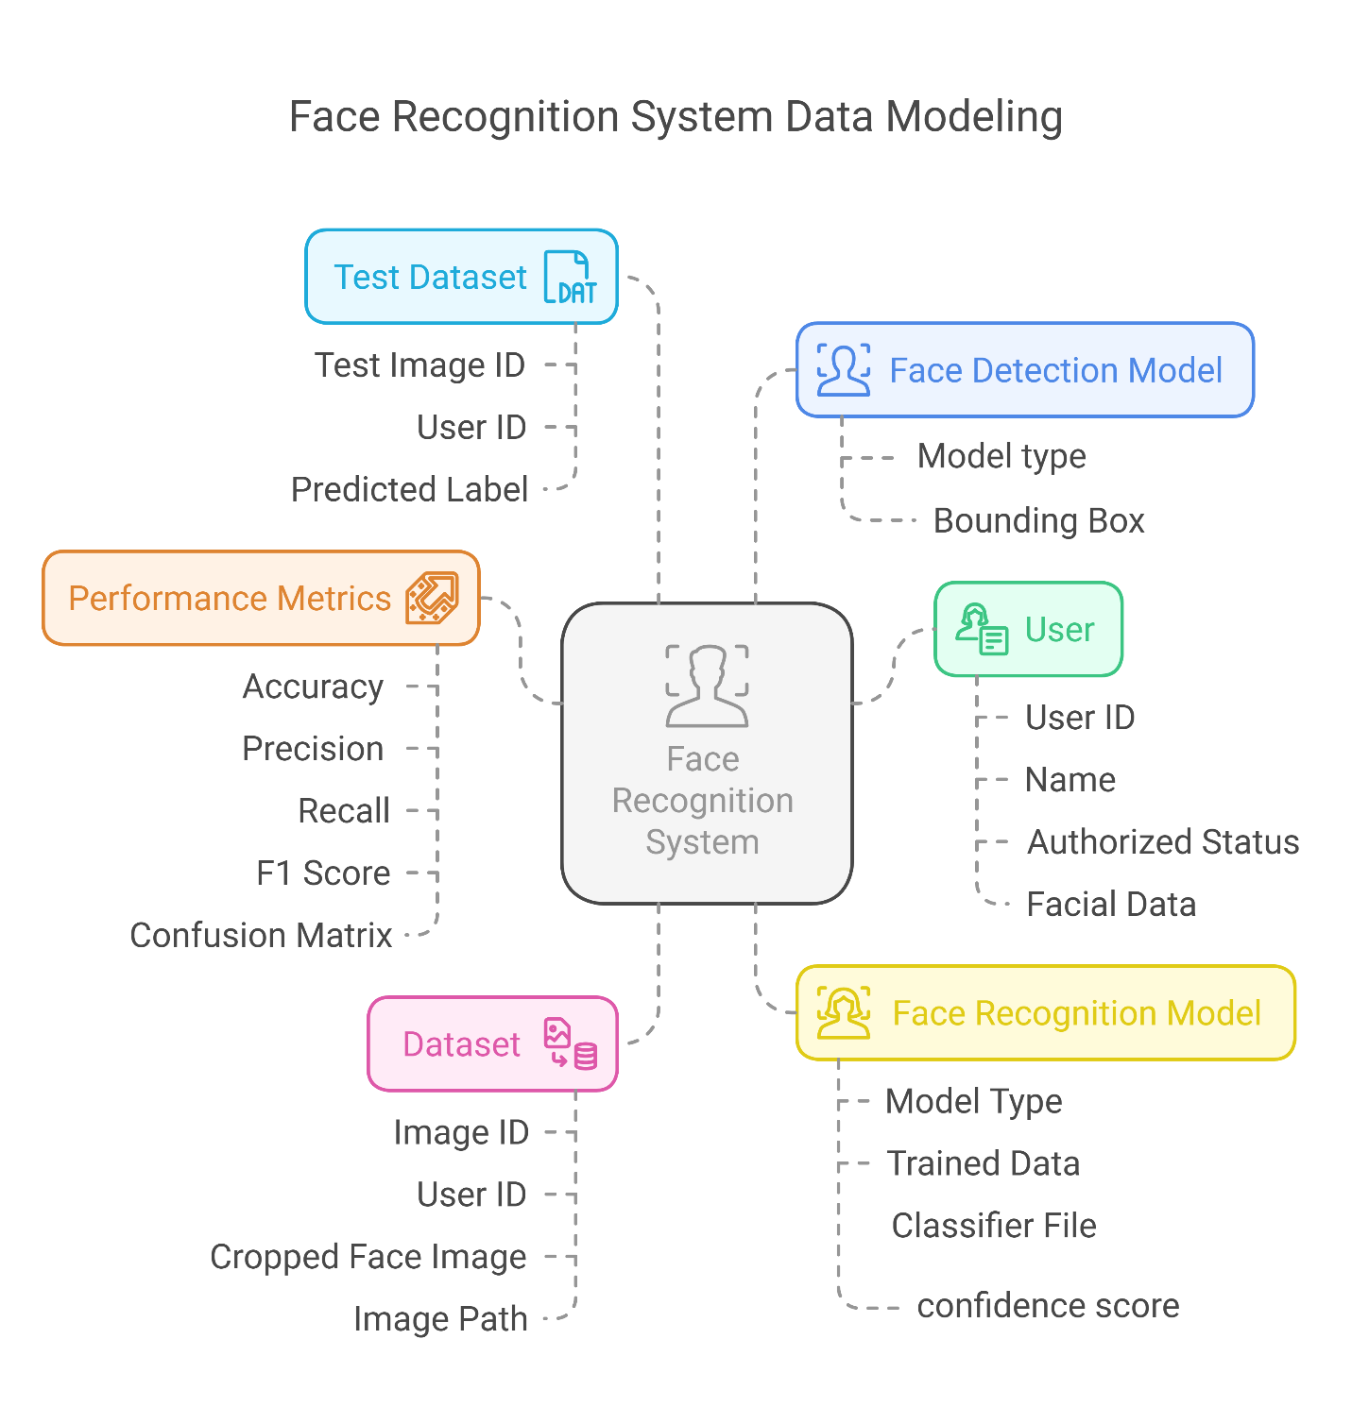
- Data Modeling:

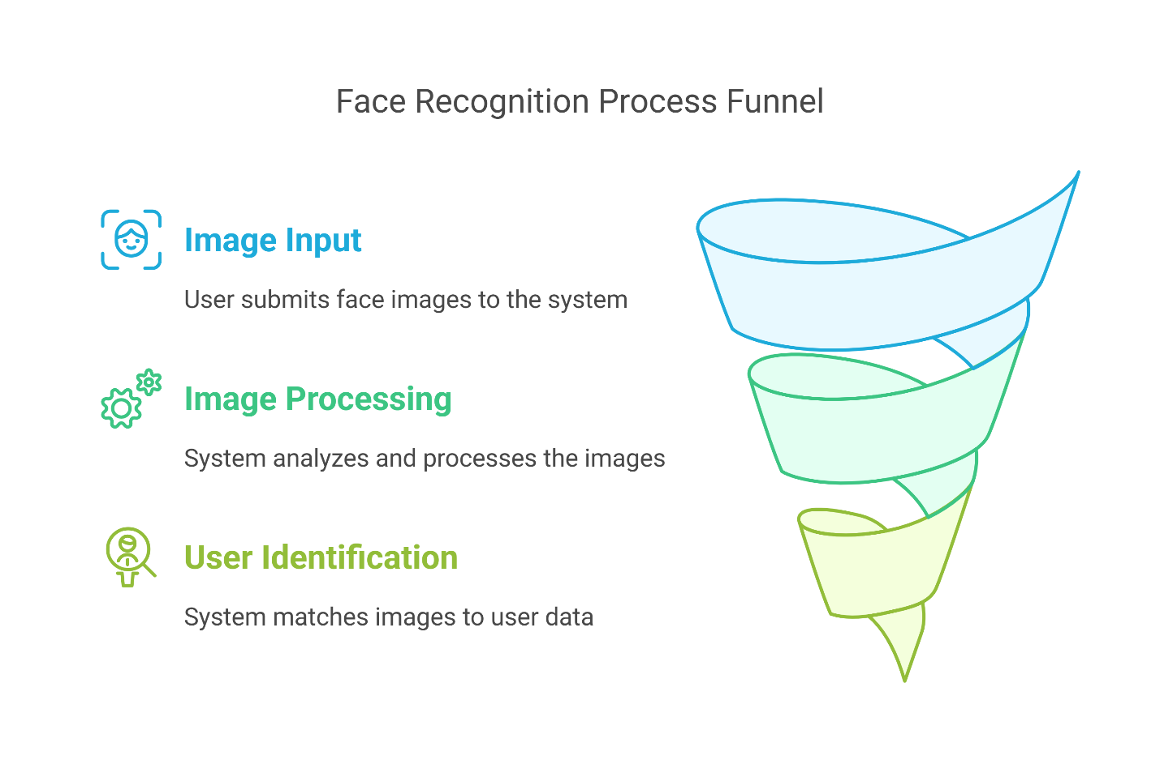
Process modeling:
Level 0:

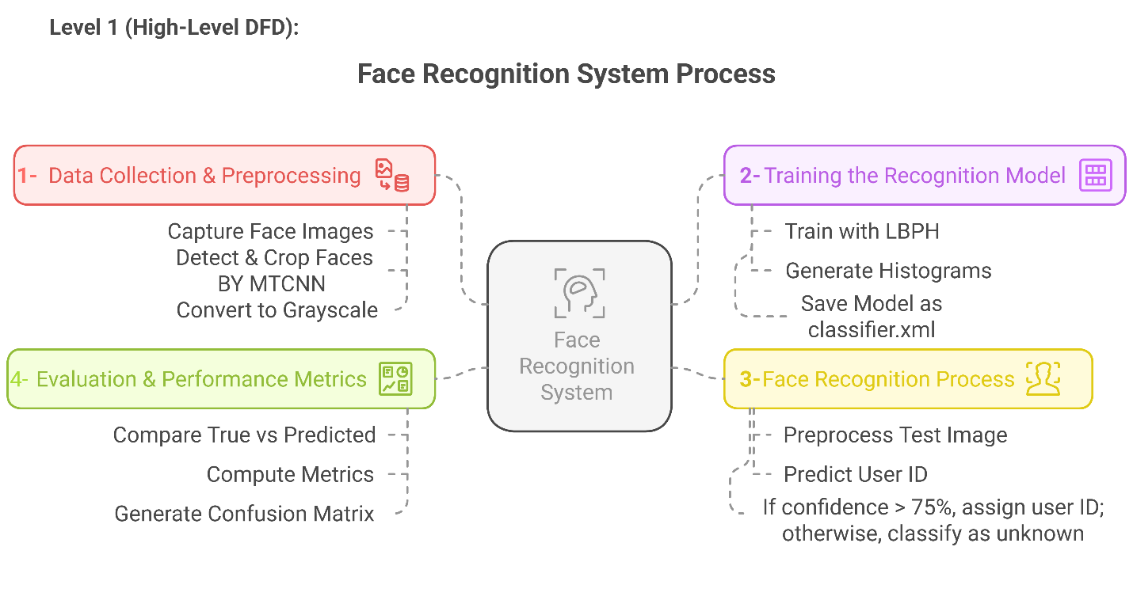

Flow chart:
